2019- 2020 Meeting Schedule
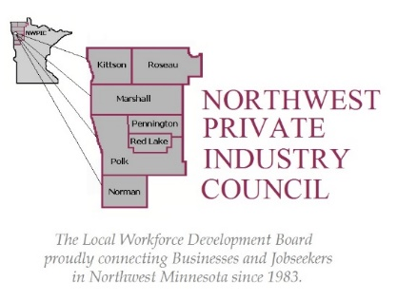

Date & Time | Location | Members | Meeting Action Items
August 16, 2019 | TRF Workforce Center  Room 739 B | Exec Committee | Review Budget, Plans, Calendar, Agenda, Appointments
September 19, 2019 | Northland Community & Technical College  Room 662 | Full WDB | Officer Elections, LMI Presentation  One Stop Operator MOU & WFC Lease  Budget Review; Regional Planning MOU
October 1, 2019  5:30 pm | NWRDC, Warren, MN | LEO – Joint Powers | Regional Planning MOU  WDB Appointments  Budget and Workplan approval
October 3, 2019 | TRF Workforce Center  Room 739 B | Exec Committee | Review Draft Work Plan  Executive Director Performance Review
November 7, 2019 | Northland Community & Technical College - Room 662 | Full WDB | Regional Workforce Strategy Consultant Update
January 9, 2020 | TRF Workforce Center  Room 739 B | Exec Committee | Audit Review  Planning for Board Retreat
February 4, 2020  5:30 pm | NWRDC, Warren, MN | LEO – Joint Powers | Audit Review  WDB Appointments (if any)
February 6, 2020 | Northland Community & Technical College - Room 662 | Full WDB | Audit Presentation and Review  Report on Executive Director Performance Review
March 5, 2020 | TRF Workforce Center  Room 739 B | Exec Committee | Budget Review and Projections
April 2, 2020  April 7, 2020 | Northland Comm & Tech College - 662  Add on Covid- 19 Phone Meeting | Full WDB  LEO Meeting | Board Retreat and Learning Session  Add on Covid- 19
May 7, 2020 | TRF Workforce Center  Room 739 B | Exec Committee | Ongoing Budget Review/Projections – Prelim Approval  Review Strategic Planning Session
June 2, 2020  5:30 pm | NWRDC, Warren, MN | LEO – Joint Powers | Review Joint Powers Agreement  Update on Strategic Planning Session – Local Plan  Final Budget Approval (if allocations rec’d from State)
June 4, 2020 | Northland Community & Technical College - Room 662 | Full WIB | Final Budget Approval (if allocations rec’d from State)  Final Local Plan Update

